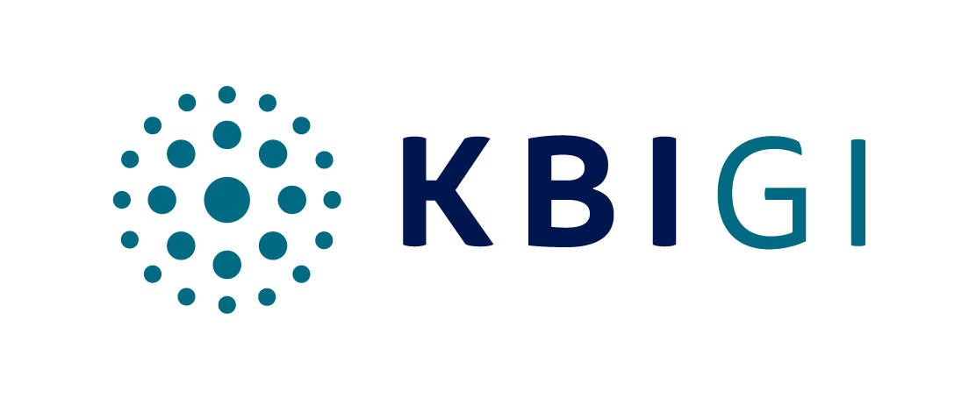

News release Thursday 25th June 2020

KBIGI PUBLISHES LATEST IMPACT MEASUREMENT SCORES FOR NATURAL RESOURCES STRATEGIES

‘RASS’ study findings underline high Revenue Impact correlation of Natural Resources Strategies’
constituent portfolio holdings to UN Sustainable Development Goals

Specialist asset management boutique KBI Global Investors was early to recognise the alpha to be derived from investing in companies providing solutions to numerous sustainability challenges relating to the provision of food, energy and water, and the mitigation of and adaptation to the impacts of climate change. As such, it aligned its investment strategies with the UN Sustainable Development Goals from their very introduction in 2015. Two years ago, with growing numbers of investors looking to achieve Impact through public equities, the Dublin-based manager announced it had quantified the revenue impact of constituent portfolio holdings in each of its Natural Resources strategies to the SDGs and published the findings of its inaugural ‘Revenue Alignment SDG Score’ research study, including a revenue impact score for each strategy. KBIGI remains one of a small band of managers with this type of capability and today released the ‘RASS’ impact measurement scores for 2019¹ for each of the strategies.

The Global Resource Solutions (‘GRS’) strategy delivered a particularly high RASS score of 74.7% i.e. the percentage of revenues contributing to the achievement of the SDGs – with SDG9 (Industry, Innovation and Infrastructure), SDG6 (Clean Water and Sanitation), SDG11 (Sustainable Cities and Communities), SDG7 (Affordable and Clean Energy) and SDG2 (Zero Hunger) the SDGs to which the GRS strategy contributes most. This is a net figure – as with the RASS scores for each of the four Natural Resources strategies – a 3.3% deduction being made to the GRS score in respect of negative contribution.

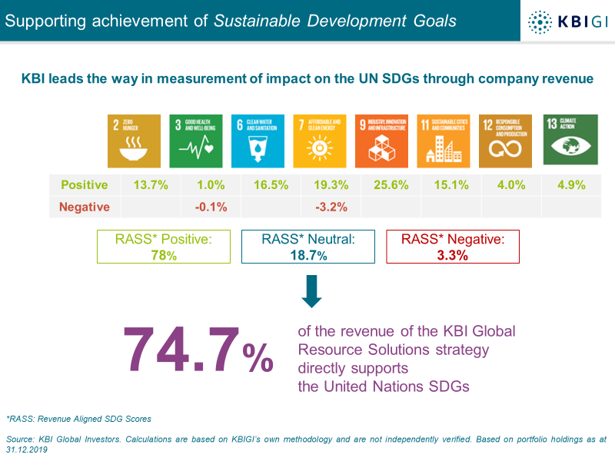
KBIGI PUBLISHES LATEST IMPACT MEASUREMENT SCORES FOR NATURAL RESOURCES STRATEGIES../2

At 82.7%, the Sustainable Infrastructure Strategy – launched three years ago – has an even higher revenue to Impact correlation, making a significant contribution to SDGs 7 and 9.

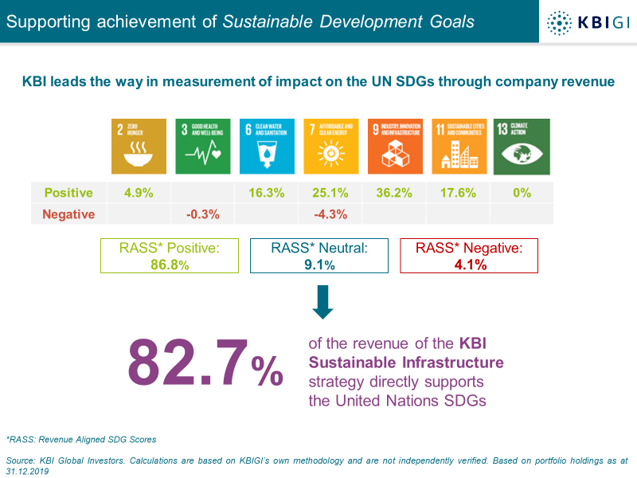

Not unsurprisingly, the Energy Solutions Strategy makes the most significant contribution to SDG7 at 41.9%.

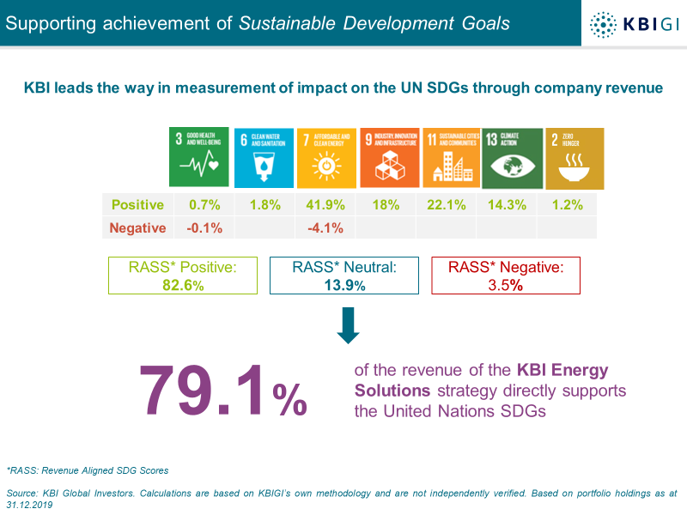
KBIGI PUBLISHES LATEST IMPACT MEASUREMENT SCORES FOR NATURAL RESOURCES STRATEGIES../3

The Water strategy has a small negative impact on just one of the eight SDGs to which it is aligned.

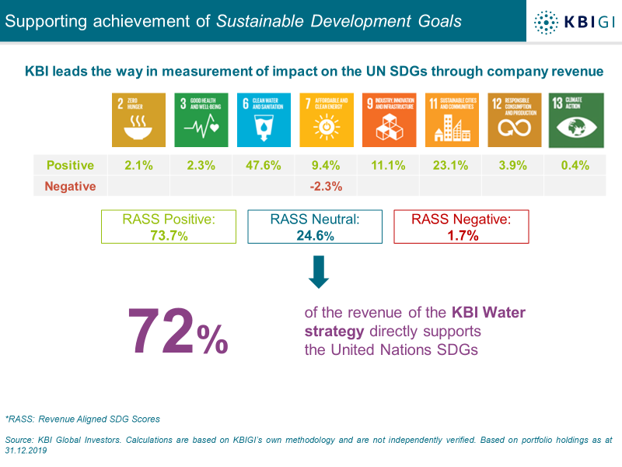

In compiling the research, the Responsible Investing Committee this year focused heavily on business activities related to fossil fuels, aerospace and emissions, the mining of lithium, the classification of Materials Treatment (which is largely related to the weight of autos) and the production of Palm Oil.

Commenting on the 2019 RASS scores, Eoin Fahy, Head of Responsible Investing said: “Rather than simply having an anecdotal sense that investments in these strategies contribute to the achievement of the SDGs, we have been able to quantify this in a replicable and transparent methodology. That we have been able to quantify the impact score of our portfolios in this unique and proprietary way gives us a clear edge, and we are not aware of any other studies that directly measure, in such fine detail, the revenues of portfolios to the UN SDGs; we believe we are one of very few managers to measure and account for a negative element within our RASS score and have this year added 13 additional business activities on the Energy Solutions strategy and nine on to the Water strategy. As investors’ appetite for Impact strategies grows it is gratifying that we can offer them a range of strategies that deliver significant and measurable Impact in such a clear and transparent way.”

KBIGI’s methodology, which is fully detailed in the accompanying report, involves identifying the various business activities of an investee company, forming a view as to the SDGs which each activity is aligned with, and the positive and/or negative contribution which each of the circa 200 activities makes to those SDGs.

– ENDS –

¹ All scores are based on the constituent portfolio holdings of each strategy at the end of December 2019, with analysis during the current quarter based on the most recent data available at the time the exercise was undertaken.

KBIGI PUBLISHES LATEST IMPACT MEASUREMENT SCORES FOR NATURAL RESOURCES STRATEGIES../4

Journalists seeking further information should contact:
Gordon Puckey
Phoenix Financial PR
+44 7799 767 468
gordon@phoenixfinancialpr.co.uk

NOTES TO EDITORS

- About KBI Global Investors (‘KBIGI’)
Established in 1980, KBI Global Investors is a specialist institutional asset management boutique, offering a range of Global Equities and Natural Resources strategies. The firm manages assets for a broad range of clients – public and corporate pension schemes, sub-advisory investors, foundations and endowments, wealth managers, private banks and investment intermediaries included. KBIGI has a global client base and today holds mandates in the UK, Europe, North America and Asia as well as for some of Ireland’s largest and best-known corporations. Part of Amundi, the firm is headquartered in Dublin, with a representative sales office in Boston, Massachusetts.

KBIGI boasts a track record of delivering consistent and outstanding risk-adjusted investment performance over the longer term, its highly experienced investment team today managing €9.0bn. (This is the combined AUM of KBI Global Investors Ltd and KBI Global Investors (North America) Ltd as at 31st May 2020).

The firm is headed by CEO Sean Hawkshaw, with members of the KBIGI team holding 12.5% of the equity in the firm.

www.kbiglobalinvestors.com

- KBI Global Investors and Natural Resources strategies
One of the firm’s principal goals is to be first to market with value-adding investment themes of the future. In the late 1990s, KBIGI was amongst the earliest investors to recognise the inherent source of alpha (the active return on an investment) from investing in companies providing solutions to sustainability challenges related to the provision of food, energy, water and the mitigation of and adaptation to the impacts of climate change.

Having identified a compelling and clear need for investment in companies providing solutions to the global shortages of clean water and energy, the firm first launched strategies in these areas in 2000. Building up its team and intellectual capital in these themes, KBIGI added a climate change strategy in 2007, a sustainable impact agribusiness (food) strategy in 2008 and a sustainable impact infrastructure strategy in 2017.

From 2018 onwards, KBIGI has been reporting on the extent to which its Natural Resources strategies contribute to the achievement of the United Nations Sustainable Development Goals (‘SDGs’). This significant initiative involves the detailed classification of all revenues of the companies held in each portfolio, determining whether the activity from which those revenues arise is contributing, positively or negatively, to one or more of the SDGs.

- Disclaimers

KBI Global Investors Ltd is regulated by the Central Bank of Ireland and subject to limited regulation by the Financial Conduct Authority in the UK. Details about the extent of our regulation by the Financial Conduct Authority are available from us on request. KBI Global Investors (North America) Ltd is a registered investment adviser with the SEC and regulated by the Central Bank of Ireland. KBI Global Investors (North America) Ltd is a wholly owned subsidiary of KBI Global Investors Ltd. ‘KBI Global Investors’ or ‘KBIGI’ refer to KBI Global Investors Ltd and KBI Global Investors (North America) Ltd.

KBIGI PUBLISHES LATEST IMPACT MEASUREMENT SCORES FOR NATURAL RESOURCES STRATEGIES../5

IMPORTANT RISK DISCLOSURE STATEMENT
Under MiFID II this is deemed marketing material and should not be regarded as investment research. This material is provided for informational purposes only and does not constitute an offer to sell or the solicitation of an offer to purchase any security, product or service including any group trust or fund managed by KBI Global Investors. The information contained herein does not set forth all of the risks associated with this strategy, and is qualified in its entirety by, and subject to, the information contained in other applicable disclosure documents relating to such a strategy. KBI Global Investors’ investment products, like all investments, involve the risk of loss and may not be suitable for all investors, especially those who are unable to sustain a loss of their investment.

