Please find attached the documents as requested.

The monthly performance figures below are for UBAM - Positive Impact Emerging Equity IC-Share net of fees, USD, ISIN: LU2051760473 (Portfolio), against  the index is the MSCI Emerging Markets Net TR USD, provided for information purposes only. The investment objective does not aim to replicate the index.

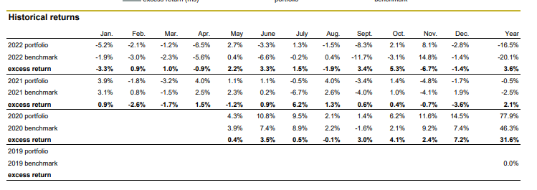

Past performance is not a guide to current or future results. See the disclaimer at the end of this document.

If you have any further queries please do not hesitate to reach out to us.

Kind regards,

**Robert Wibberley**

Corporate Communications & Content Manager

Group Communications  
Union Bancaire Privée, UBP SA  
Rue du Rhône 96-98 | P.O. Box 1320 | CH-1211 Geneva 1  
T. + 41 58 819 26 85 | [robert.wibberley@ubp.ch](mailto:robert.wibberley@ubp.ch)