**Best ESG Investment Fund: Emerging Markets**

**Company:** SilverStreet Capital

**Fund:** Silverlands

**Submission:**

SilverStreet Capital (SilverStreet) is a UK and Africa based investment advisor managing African agricultural funds. Its objectives are to achieve a positive long term social, environmental and climate impact whilst making attractive returns for investors.

SilverStreet has integrated ESG into all stages of the investment cycle. See our Impact and ESG policy [here](https://www.silverstreetcapital.com/policies).

Key to this success has been SilverStreet’s unique annual ESG independent audits and the large on-the-ground ESG team.

Independent ESG Audits

SilverStreet conducts annual independent ESG reviews of the Silverlands Funds. The resulting reports are highly detailed (~70 pages each) and show the increase in ESG implementation over the holding period. This is demonstrated through compliance with SilverStreet’s Responsible Investment Code, for example:

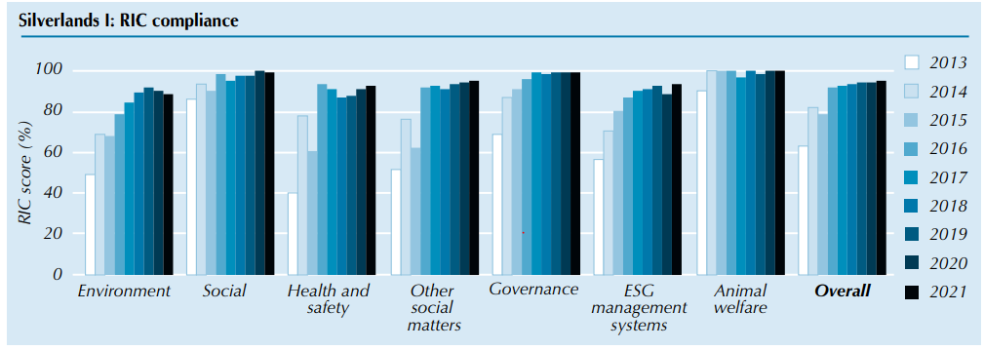

All these ESG reports are shared with investors and presented annually to investors.

ESG Team

Building a dedicated inhouse ESG team has been essential to the successful management of ESG aspects. There are now 21 personnel with ESG responsibilities across SilverStreet and its portfolio. See the team [here](https://www.silverstreetcapital.com/silverlands-esg-team).

SilverStreet’s ESG and Impact Team oversees ESG implementation across the entire investment cycle, reports on ESG, and supports portfolio companies to implement the ESG standards. They maintain day-to-day contact with, and provide training to, portfolio companies and make regular site visits.

A challenge upon entering the African agricultural sector was the lack of personnel with ESG experience. SilverStreet saw this as an opportunity to build a dedicated team.

Every portfolio company appoints an ESG manager who is supported by SilverStreet’s ESG team. These people oversee ESG matters, including assessing ESG risks. The team now consists of eighteen ESG personnel. This invaluable strategy ensures that ESG will be managed properly post-exit.

**Supporting material sent via email.**

**SilverStreet’s Annual Impact and ESG Report is available** [**here**](https://www.silverstreetcapital.com/annual-reports)**.**