Dear Matthew,

many thanks for reaching out.

Please find attached the requested documents.

First, I like to send you the documents for the

**Multi Asset: SDG Evolution Flexibel**

You will find details regarding our impact measurement in our Presentation 2023 January.

This fund is absolute return and does not have a benchmark (certainly, we compare with peers)

Here are the performance numbers net of fees:

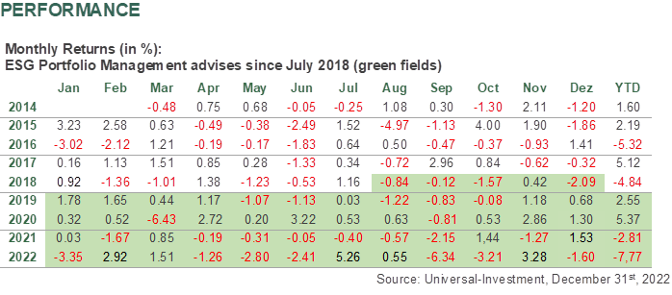

2023 is as at January 13th +4.0%

Kindest regards and best greetings

Christoph

Mit freundlichen Grüßen

Christoph Klein, CFA, CEFA

Managing Partner

ESG Portfolio Management GmbH

