* KIID and factsheet/prospectus
  + ESG Advantage is not a UCITS fund, so we do not maintain a formal KIID.
  + In its place, please find our current Factsheet and presentation deck attached.
* Impact report (where available)
  + Welton calculates ESG Advantage’s ESG score relative to the benchmark S&P 500 Index and shares these results every month on the front page of our factsheet. (See attached, and repeated below).
* 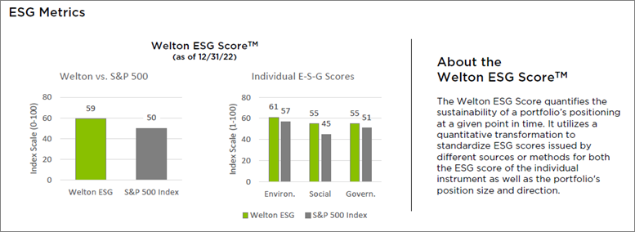
  + As one of the first alternative multi-asset ESG programs created, Welton had to innovate to develop an ESG scoring methodology that could evaluate all four major asset classes: commodities, currencies, equity indices, and fixed income.
  + To construct our portfolio, we then needed to normalize these scores for comparison, answering previously uncontemplated questions, such as, “which is more ESG, Soy Beans or the Mexican Peso?” This transparent and rules-based approach is consistent with our firm’s 30-year history as a systematic macro investor, but it took considerable innovation on our part to pioneer unexplored asset classes within ESG investing.
  + An overview of these two processes (instrument scoring and complex portfolio ESG scoring) is described in the attached two whitepapers.
* Most recent annual report (or semi-annual report)
  + We do not produce an annual report.
  + Instead, we provide detailed market/trading commentaries and data updates in our monthly factsheets.
* Monthly total net returns after fees and costs since inception as well as the total monthly return on the fund’s benchmark
  + See the attached Excel return file.
  + Summary table is repeated below, and spans the period of June 2020 (inception) through Dec 2022.
    - 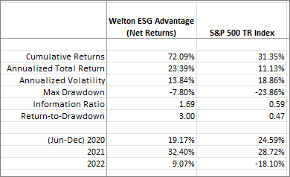

________________________________  
**Christopher Keenan**   
Director of Marketing  
Welton Investment Partners LLC  
(831) 620-6607  
[ckeenan@welton.com](mailto:ckeenan@welton.com)

THE INFORMATION CONTAINED HEREIN IS NOT FOR RETAIL INVESTORS BUT INTENDED FOR USE BY INSTITUTIONAL AND PROFESSIONAL INVESTORS INCLUDING “QUALIFIED PURCHASER” WITHIN THE MEANING OF THE 1940 ACT WHICH ALSO QUALIFIES IT FOR THE STATUS OF “QUALIFIED ELIGIBLE PERSON” UNDER CFTC REGULATION 4.7. THE TRADING PROGRAM DESCRIBED HEREIN IS SPECULATIVE, INVOLVES SUBSTANTIAL RISK AND IS NOT SUITABLE FOR ALL INVESTORS.  NO REPRESENTATION IS BEING MADE THAT ANY INVESTOR WILL OR IS LIKELY TO ACHIEVE SIMILAR RESULTS. THIS DOCUMENT IS NOT A SOLICITATION FOR INVESTMENT.  SUCH INVESTMENT IS ONLY OFFERED ON THE BASIS OF INFORMATION AND REPRESENTATIONS MADE IN THE APPROPRIATE OFFERING DOCUMENTATION. PAST PERFORMANCE IS NOT NECESSARILY INDICATIVE OF FUTURE RESULTS.

THE CONTENTS OF THIS MESSAGE, TOGETHER WITH ANY ATTACHMENTS, ARE INTENDED ONLY FOR THE USE OF THE INDIVIDUAL OR ENTITY TO WHICH THEY ARE ADDRESSED. IF YOU ARE NOT THE INTENDED RECIPIENT, YOU ARE HEREBY NOTIFIED THAT ANY DISSEMINATION, DISTRIBUTION, OR COPYING OF THIS MESSAGE, OR ANY ATTACHMENT, IS STRICTLY PROHIBITED. IF YOU HAVE RECEIVED THIS MESSAGE IN ERROR, PLEASE NOTIFY THE ORIGINAL SENDER.